**Assignment Tasks**

**Question 1.** Write an SQL query to find the names of restaurants that have at least one menu item with a price greater than $10.

**Question 2.** Write an SQL query to retrieve the user names and their corresponding orders where the order total is greater than the average order total for all users.

**Question 3.** Write an SQL query to list the names of users whose last names start with 'S' or ends with ‘e’.

**Question 4.** Write an SQL query to find the total order amounts for each restaurant. If a restaurant has no orders, display the restaurant name and a total amount of 0. Use the COALESCE function to handle null values.

**Question 5.** Write a query to find out how many orders were placed using cash or credit.

**Solutions:**

1. SELECT DISTINCT B.name

FROM restaurant_info B

WHERE B.restaurant_id IN

(

SELECT A.restaurant_id

FROM menuitems A

WHERE A.price >10

);

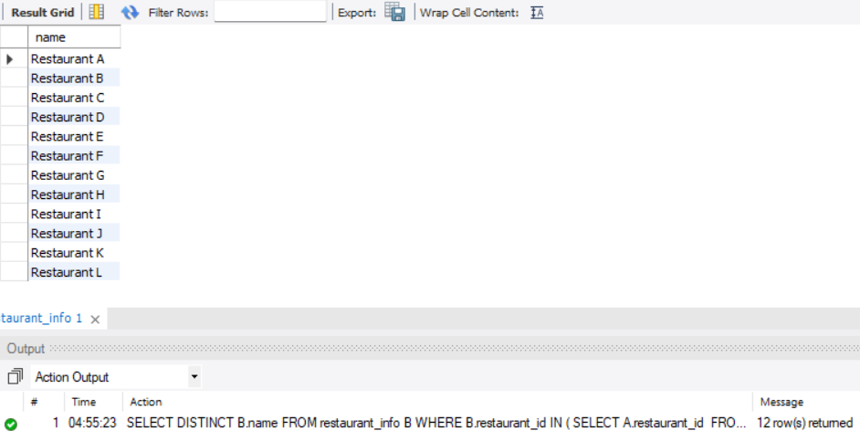

1. SELECT B.name User_Name, A.order_id Order_ID, A.total_amount AS Total_Amount

FROM orders A Left JOIN user_info B

ON A.user_id = B.ID

WHERE A.total_amount >

(

SELECT AVG(A.total_amount)

FROM orders A

);

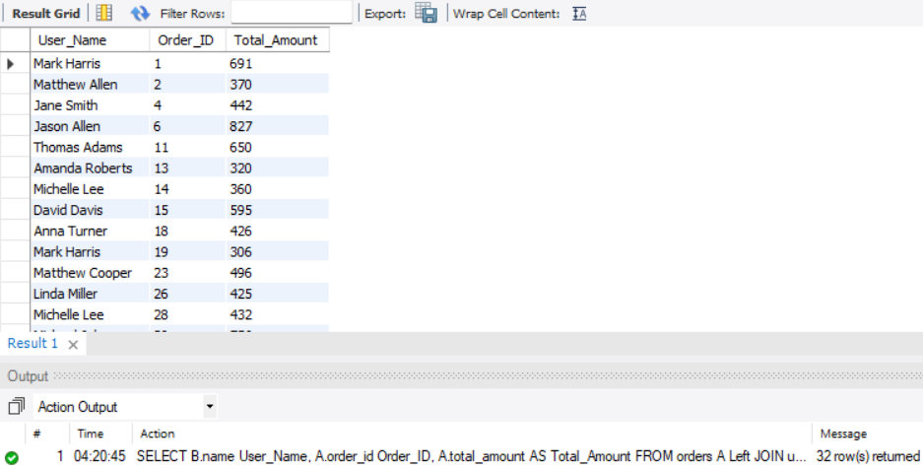

1. SELECT name FROM user_info

WHERE SUBSTRING_INDEX(name, ' ', -1) LIKE 'S%' OR SUBSTRING_INDEX(name, ' ', -1) LIKE '%e';

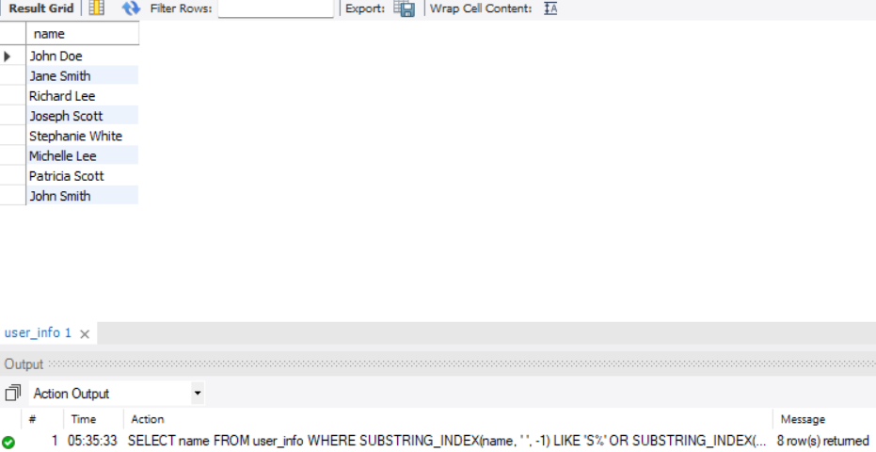

1. SELECT B.name Restaurant_Name, SUM(COALESCE(A.total_amount, 0)) Total_Amount

FROM Orders A LEFT JOIN Restaurant_info B

ON A.restaurant_id = B.restaurant_id

GROUP BY B.name;

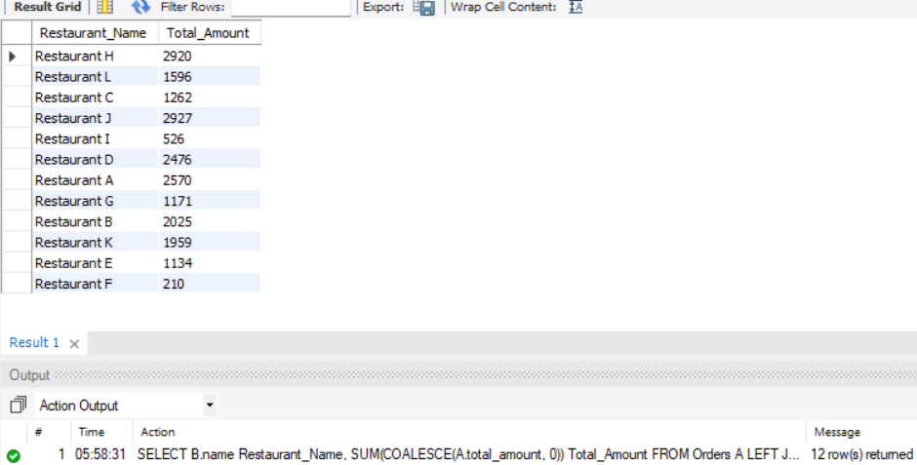

1. SELECT A.name, COUNT(C.order_id) Orders

FROM payment_type A LEFT JOIN payment_transactions B

ON A.pay_type_id = B.pay_type_id

LEFT JOIN orders C

ON B.order_id = C.order_id

GROUP BY A.name;

